DATA ANALYSIS REPORT

Introduction:
Access to Github- https://github.com/malvikaoke/Restaurant-Project.git
This report provides information obtained through a real dataset for the Restaurant Business in the US for the year 2020 and how the pandemic has affected the hospitality industry. There are 3 different organisations that have ranked these restaurants based on several variables.
Furute50 data measures the fastest growing restaurants with their annual sales growing between $20-50million dollars a year.
Top250 data measures the largest restaurants in the country and their annual sales from the year 2019.
Independence100 measures the highest grossing restaurants based on 5 locations in the US.
Data/Process and Result
The first dataset I analysed was the Future50 ranking. This data includes 50 columns and 9 rows. I have taken into account restaurant rankings, location, YOY sales and franchise. It is noticeable that New York which is a popular city in the US, have 8 restaurants in the top50 rankings, out of which two have a franchise.
As visible below in Image 1 and Image 2, I sorted the data based on Location, and then specifically New York.
Image 1
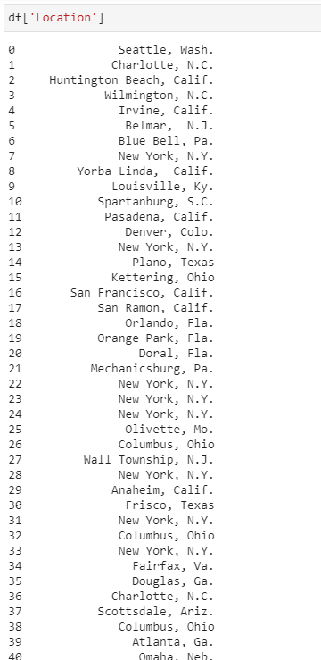
This data was the sorted based on restaurants that have a franchise and ones that don’t. I calculated the total sales for both and it’s noticeable that the restaurants who don’t have a franchise have higher sales.

Image 2
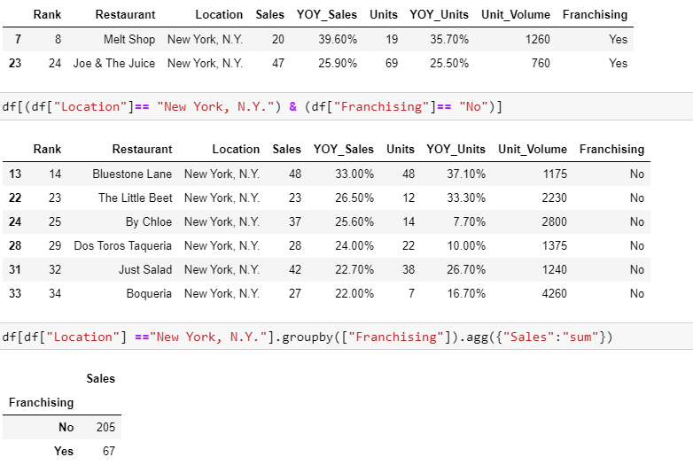
As visible below in Image 3, I used the dataset from Top250 rankings. The rows (Restaurant and Segment Category) were retrieved using the .loc function. The first 5 rows were selected. This was then categorised by the restaurants that had a ‘Quick Service & Chicken’ category.
Image 2
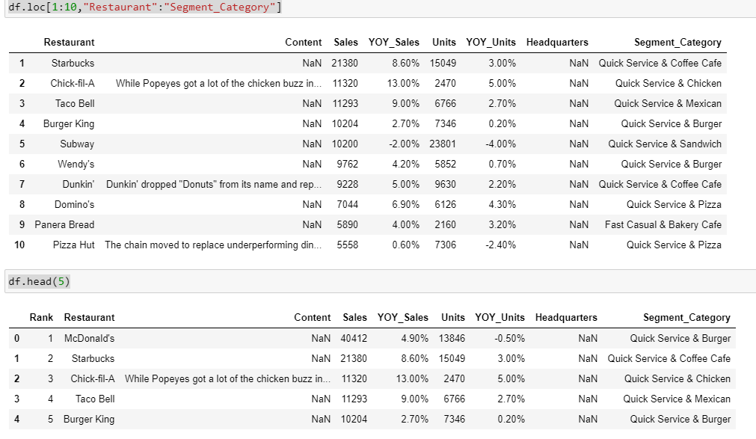
To find out which restaurant had the most sales, I sorted the data using the .sort_values function. The first 15 rows were selected. Noticeable from Image 3, McDonalds have the highest sales, due to its quick service.

Image 3
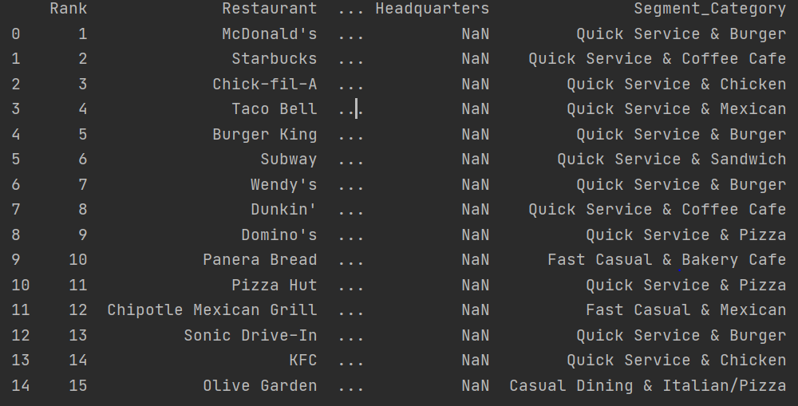
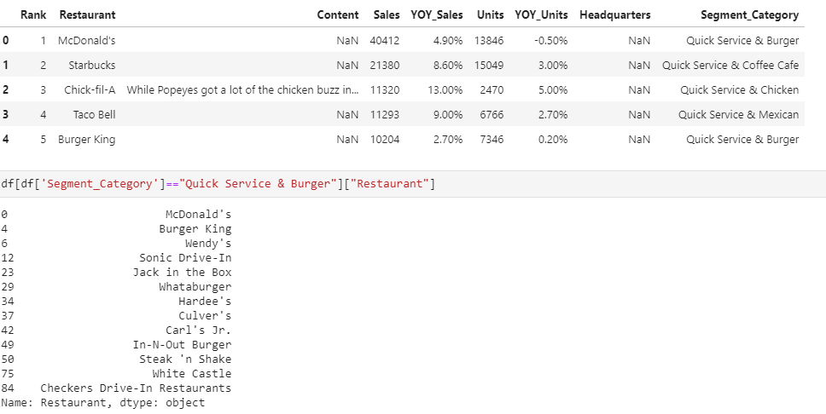

Conclusion:
Based on my findings, I can see that Burger Restaurants had the highest sales in 2020, with McDonald’s in the lead. Quick Service is the best solution in generating higher sales. Smaller companies are seem to do better than larger companies.

Bibliography:
Article title: | Restaurant Business Rankings 2020
Website title: | Kaggle.com
URL: | https://www.kaggle.com/michau96/restaurant-business-rankings-2020

